
Dedicated to the preservation of ΚΚΓ badges…. 2003 Province Meetings Edition

keepers of the key


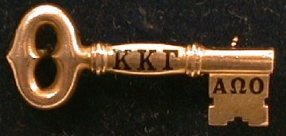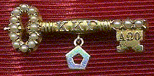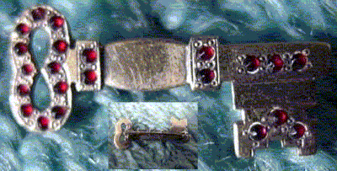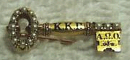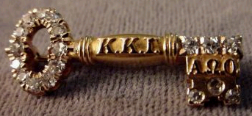
who we are…
what we do…
how we do it…
introduction…
how to join us…
rescued
rescued
rescued
lost
lost
Maybe you’ve heard about us from a member of your local Alumnae Association who bought a vintage badge from us to replace her lost or stolen badge. Maybe your chapter has received an award badge or a display badge culled from our efforts. Maybe you read about us in the Fall 2001 issue of The Key. “The Keepers of the Key,” as we informally call ourselves, are Kappa alumnae and collegiate members—tied together informally through the internet—who are dedicated to redeeming ΚΚΓ badges and keeping them in the hands of sisters.

This crusade to redeem badges is an individual effort among a band of sisters who are dedicated to assuring that our badges remain symbols of membership rather than jewelry and collector pieces. Our group includes national officers, local advisers, active alumnae, and collegiate members. We are Kappas from different backgrounds, lifestyles, and age groups, but we all share a passion for keeping ΚΚΓ badges and other important Kapparobilia in the Kappa “family.”

Since the advent (and widespread popularity of ebay), ΚΚΓ badges, like many other NPC and IFC membership badges have become highly collectible items. We work to ensure that ΚΚΓ badges stay in the Kappa family, not in the hands of non-Kappa collectors. We have rescued several historically significant pieces which have been put on display at HQ and the Heritage Museum. Some of us keep collections of our own—one member of our group has rescued 5 badges from Delta, her home chapter. Some of us pass badges along to other sisters for the same price we paid to rescue it. Often we help sisters replace lost or stolen badges with “orphan” badges of the same or similar vintage. Particularly rewarding are the rescues that allow us to return a lost or stolen badge to its original owner.

When one of us finds a ΚΚΓ badge or other significant piece of Kapparobilia on ebay, we email HQ with the initiate’s name or initials, date, and chapter to receive current information about the member. If she is living and not “lost” (no current address), group members try to reach her and usually the member is delighted that her badge has been found and she has the opportunity to buy it back. In other instances, the member may be deceased or have resigned or may simply state that she wishes her badge to be available to another Kappa to purchase and enjoy. We work within our group and in the larger Kappa community to find Kappa homes for these badges.

We need help on a number of levels—from finding homes for rescued badges to financial support to maintaining our databases of badges sold online. We invite any Kappa sisters who might want to join our ranks to help keep Kappa badges “in the family” to check out the information on back of this flyer. We look forward to hearing from you soon!
Loyally,

The Keepers of the Key

Frances Simpson

4.19.1882

Upsilon/Northwestern U.

Along with her sister Katherine, Frances was initiated day after the chapter was installed and its 5 charter members were initiated.
some recent historical saves…

Unknown

Circa 1890

Set with garnets. The letters have been polished off this badge, but a small “KKGamma" is engraved on its backside.

Isabel “issy” Hatton

10.25.1928

Beta Nu/Ohio State U.

The pentagon dangle on this badge indicates that Issy served as Editor of The Key. This badge is now on display in the Heritage Museum.
…and a few “key” losses

Elizabeth Pearl Brown

10.19.1898

Beta Tau/Syracuse U.

Custom-designed badge, set with crown pearls.

Martha PettiJohn Schulze

1923

Gamma Delta/Purdue U.

Set with mine-cut rose diamonds. Martha’s sister Althea was initiated at the Gamma Delta chapter in 1924. Their great-great-grandfather Lilburn White was reputed to have been active on the Underground Railroad.
Get In On The Action!

I want to join the group!
If you are interested in helping rescue ΚΚΓ badges, or if you just want to become involved with our efforts, please email us at: kkgebay@yahoogroups.com and let us know of your interest!

I want to buy a vintage badge!
If you are looking to purchase one (or more) ΚΚΓ badges to start a collection or to replace a lost badge, we’d love to help you…and rescue a badge to keep “in the family” at the same time! Please email us at: kkgebay@yahoogroups.com and let us know what kind of badge(s) you’re looking to acquire.

I want to help out financially!
Interested in helping our cause, but not looking to buy a rescued badge yourself? We are currently looking into setting up a fund from which we can draw to help defray the costs of rescuing ΚΚΓ badges, particularly those badges with historical significance. Please contact Mary Silzel at mrsilzel@earthlink.net.

Don’t let your badge end up on ebay!

So many of the badges we rescue come from estate sales. We find that more often than not, relatives of deceased Kappas often don’t know what to do with a membership badge, or might not even know what significance the badge holds.

The Fraternity Bylaws, Article XIX, Section 1, A, 3 states:

Badges are worn as an emblem of membership. When membership is terminated, the badge is to be returned to Fraternity headquarters. When the badge is received, one-third of the purchase price will be sent upon request. The badges of deceased members should be returned to Fraternity Headquarters unless provision in keeping with the tradition of the Fraternity for the disposition of the badge has been made by the member, her family or her chapter.”

It’s never too early to prevent your badge from ending up on ebay, a pawn shop, or a non-Kappa’s badge collection someday. Consider the following options, check one, and keep this sheet near your badge or in your badge box.

❑ I wish to have my ΚΚΓ membership badge buried with me when I pass away.
❑ I wish to have my ΚΚΓ membership badge given to _____________________________,
who was initiated at __________________________ Chapter on _____________________.
❑ I wish to have my ΚΚΓ membership badge returned to ____________________ Chapter
to be used as _____________________________________________________________.
❑ I wish to have my ΚΚΓ membership badge returned to ΚΚΓ Fraternity Headquarters at 530 East Town Street, Columbus, OH 43215.
Signature _______________________________________ Date _______________

…by the numbers…

…41 and growing… number of members of the Keepers of the Key involved in the “Kappa Ebay Rescuers” Yahoo Group.

…123… number of ΚΚΓ badges rescued from ebay, antique stores, pawn shops, flea markets, and greek badge collectors in the last year.

…27… number of ΚΚΓ badges returned to their original owners after being lost or stolen in the past year.

…51… number of ΚΚΓ badges we weren’t able to rescue to do outbidding, lack of funds, lack of support, etc. in the last year.

…1875… the oldest badge we’ve rescued to date (Josephine Hayes, Iota/DePauw—the 15th initiate of Iota in the 1st initiation held following Iota’s installation and chartering.)

…1997…the newest badge we’ve rescued to date (Alexandra J. Littlejohn, Delta Kappa/U. of Miami)
…$2,000… the most costly badge rescued so far (Annie Bell Sargent, Beta Alpha/U. of Pennsylvania, 1895).

…$12… the best bargain we’ve gotten so far…(Selma Viola Russell, Beta Delta/U. of Michigan, 1916).

…$260… the average price of a vintage badge.

